1. Sir Details are not showing in the category list, mega tag title, description, keywords empty details **DONE**

Reply: It’s not done, now it is showing all the fields but same data. Instead it should show respective data like title will show the title and description will show the descriptions.

1. category list m agr kisi category ko update kare to category hi delete ho jati hai, mene reet ki krke try kiya tha reet level 1st & 2nd **DONE**

Reply: When you add book then you can see the deleted category but those are not appearing in the main category list.

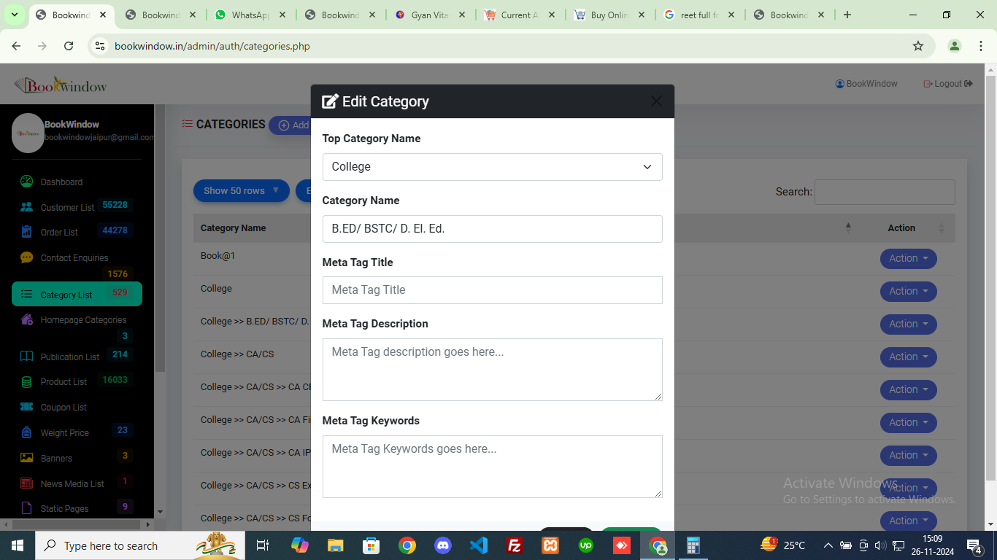

1. Sir, some publications are not being shown in this - example Moomal Publications, Utkarsh Classes, Magazines, etc. **DONE**

Reply: Utkarsha classes and magazines are still not showing.

1. Some publications may not be getting book listings, EXAMPLE :- gyan vitan publication,baudhik prakashan,devanda publication,jaypee book, neelkhant publishers nk Etc. **DONE**

Reply: Still the books with shared publications are not visible or appearing in the website frontend.

1. 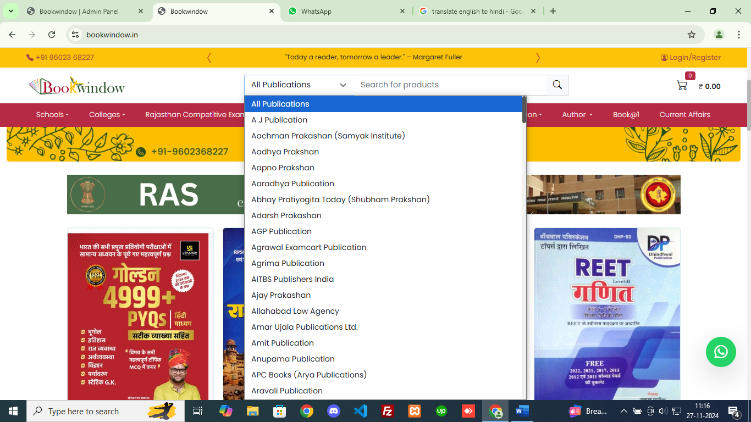
2. Need MRP and Sale price With Discount But discount % should be reflect on Right Top Hand **DONE**

Reply: Still we are missing %discount value.



1. Please check after clicking its getting 404 error <https://bookwindow.in/404.php>
2. Mobile categories still different from desktop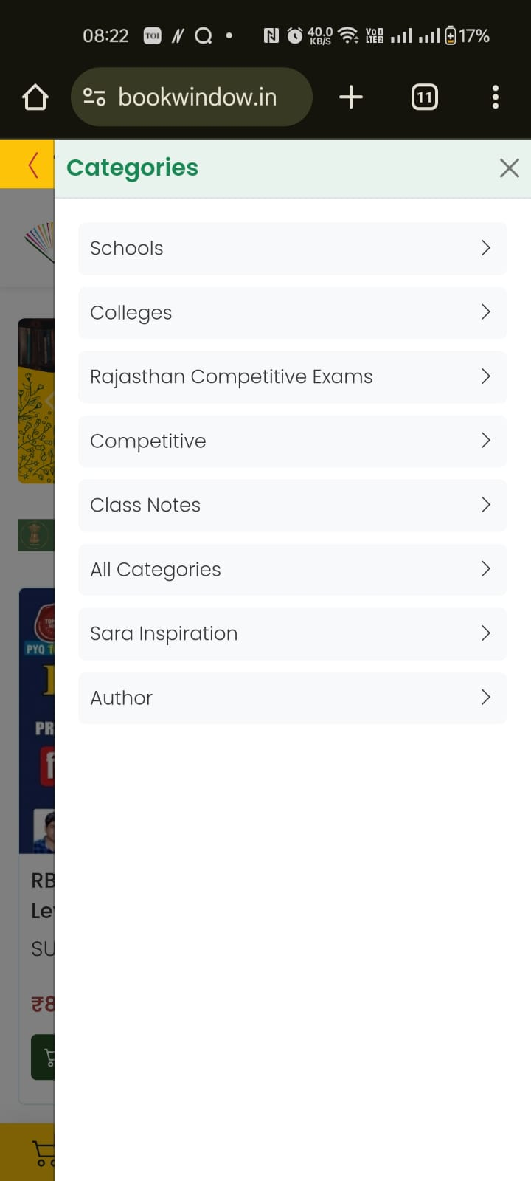
3. **Deliver to,** **DONE**

**Name:-**

**Address:-**

**City:-**

**District:-**

**State:-**

**Pin code:-**

**Phone:-**

**Email:-**

1. **Shipping from DONE**

**BOOKWINDOW**

**Store:-** Shop No. 8, Maharani Garden road

near by Hotel Dwarika Palace, Mangyawas,

Jaipur, Rajasthan

**Pin Code-** 302020

**Phone No:**- +91 96023 68227

**E-mail ID:-** [info@bookwindow.in](mailto:info@bookwindow.in)

**Website:**- [www.bookwindow.in](http://www.bookwindow.in)

**Order details DONE**

Invoice date:-

Order Id:-

Payment Method:- **AMOUNT PAID* / COD\***

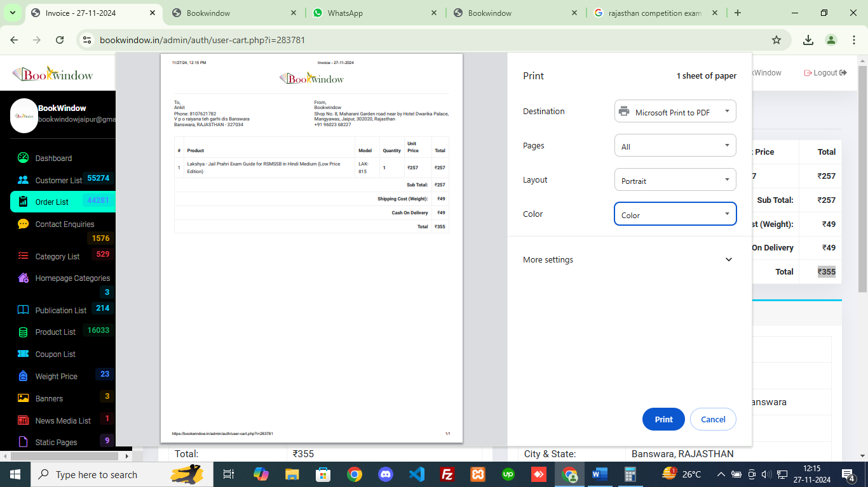

1. No Emails on order updates

Reply: Do we have any response on this?

1. Book uploaded selected category is not showing sir **DONE** **This one working**

Reply: Not working

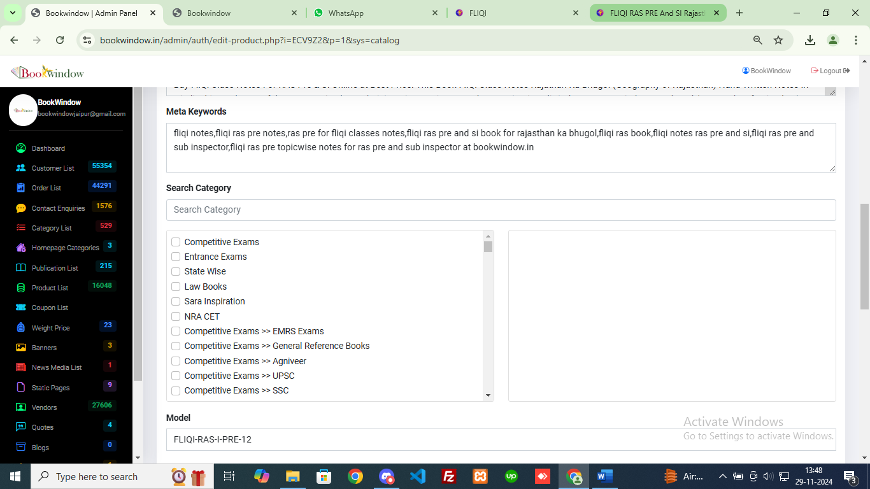

1. while editing the book he is asking the number of pages. **DONE**

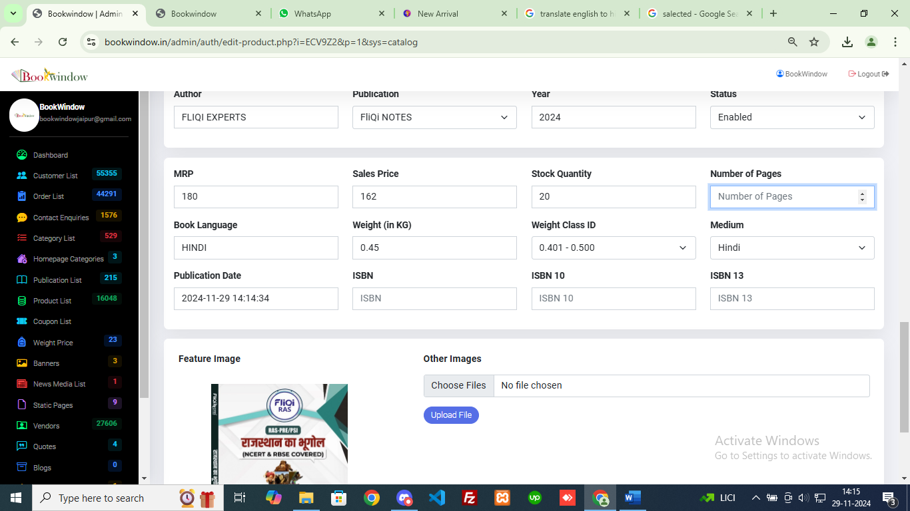

**Pending points**

1. Please add third option copy the product, after edit and view

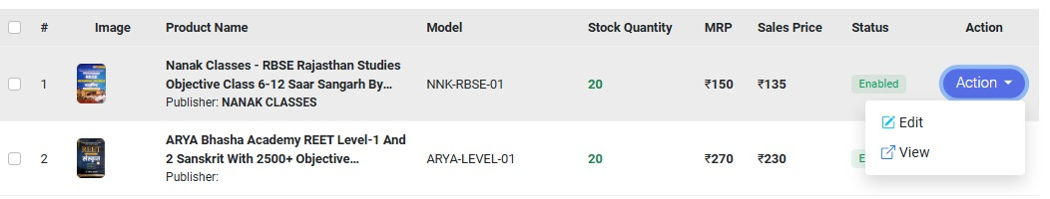

1. Discount should be reflect on Right Top Hand

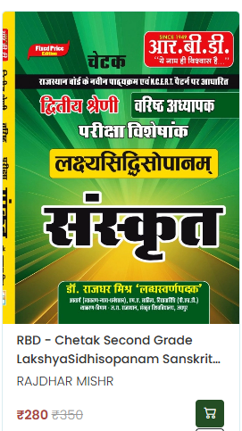

1. Sir Please Add REET LEVEL 1 & 2 Categories in submenu.



17. Book Updated selected category is not showing sir

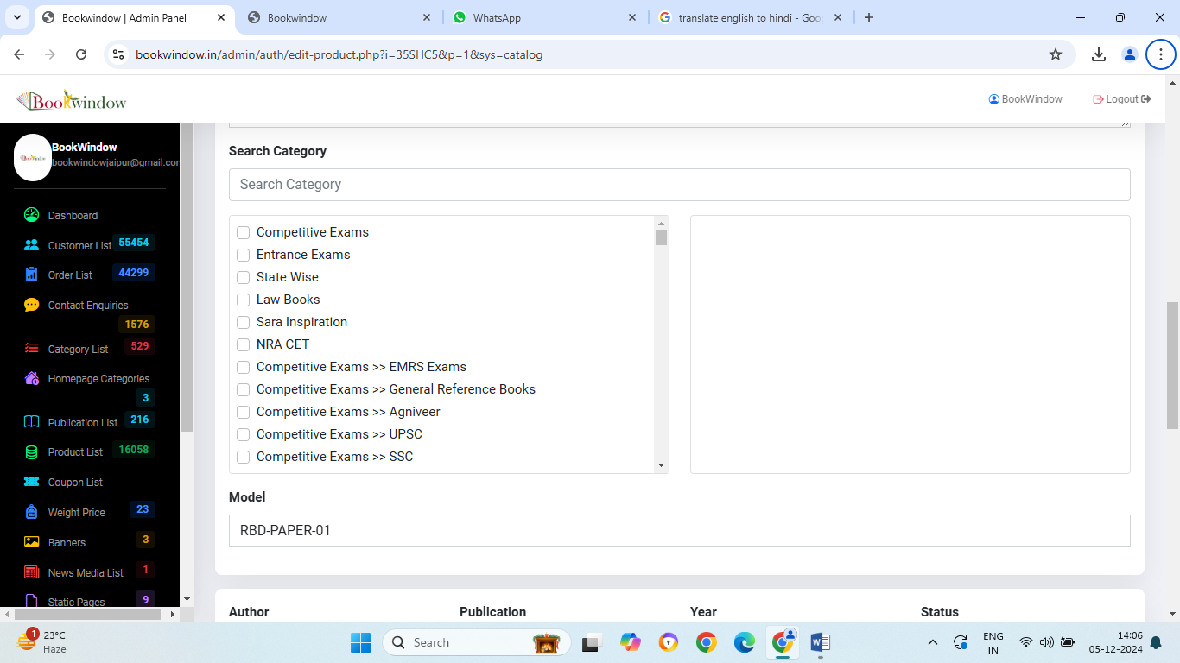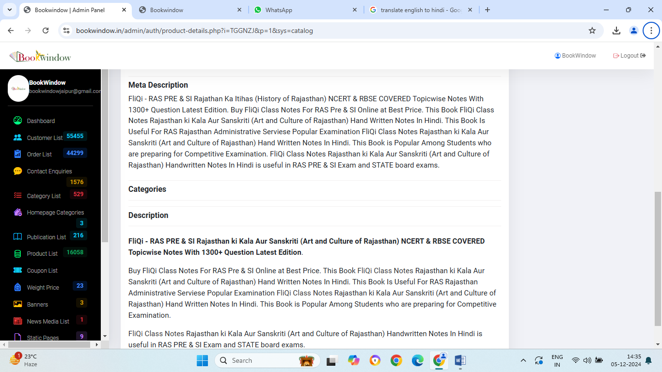

18.SIR OLD books UpDated Ki LISTING KO CATEGORY & SUB-CATEGORIES ME ADD karwa Djiye.



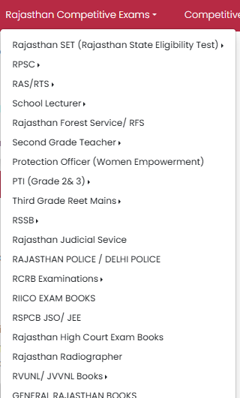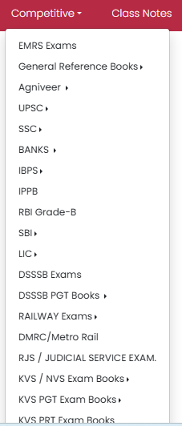

19. Please Create Excel sheet of Order List.

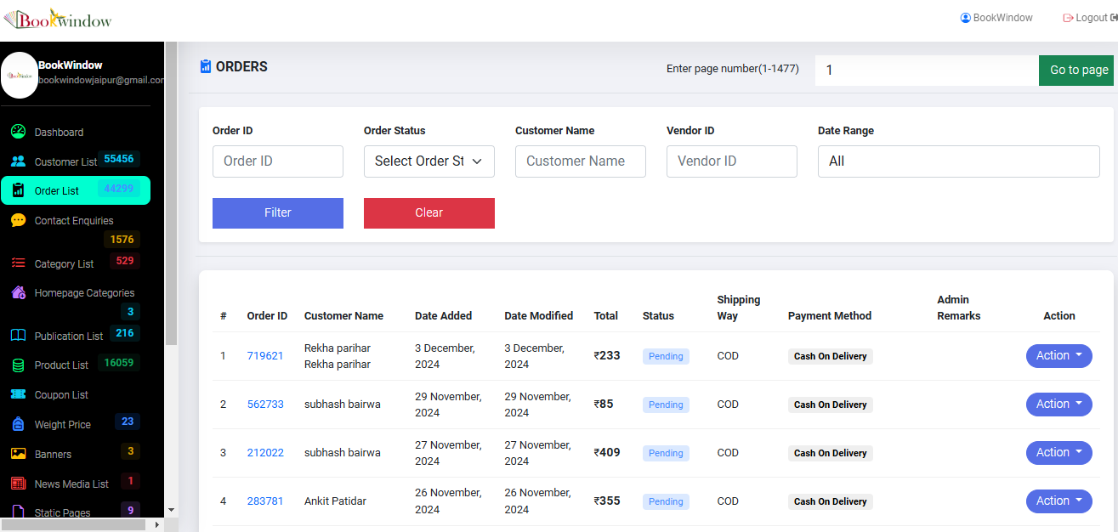

20. Book Quantity is 20 but Order Generated hone par 19 is not visible.

